OBSERVATION1

When entered alphabet in customer name field, error should be different for example: minimum 2 alphabets required.1

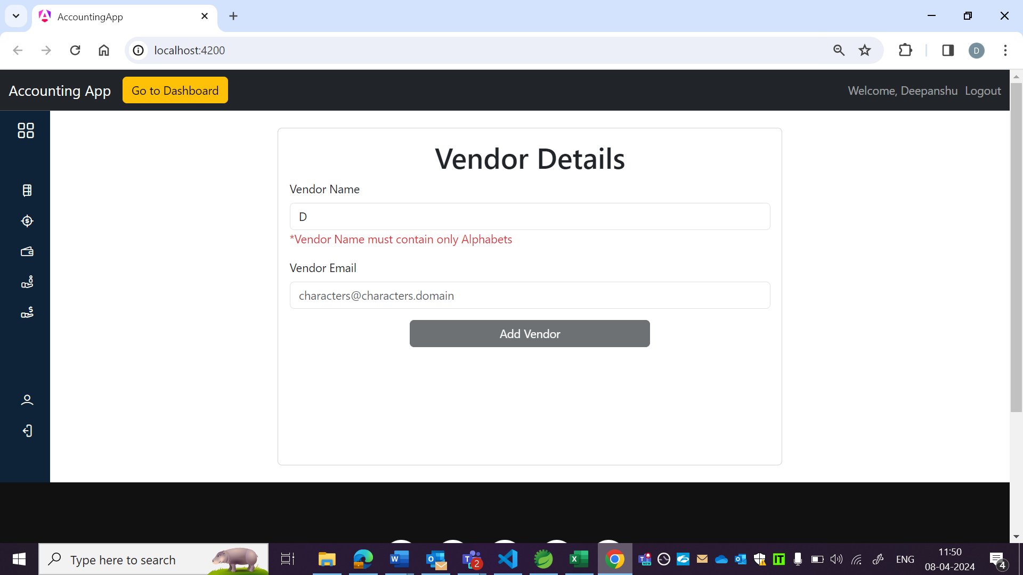

OBSERVATION2:

VendorID should not be displayed as per US.

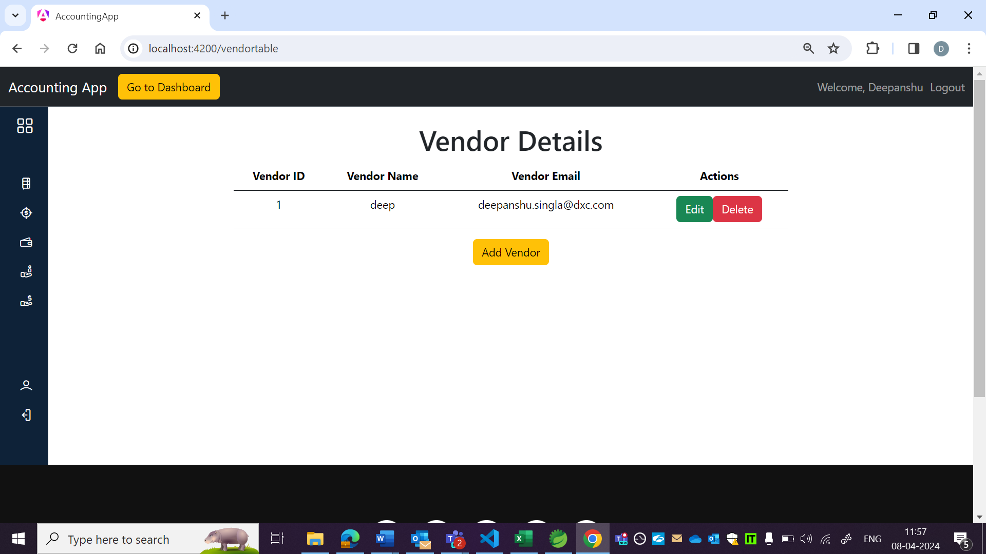 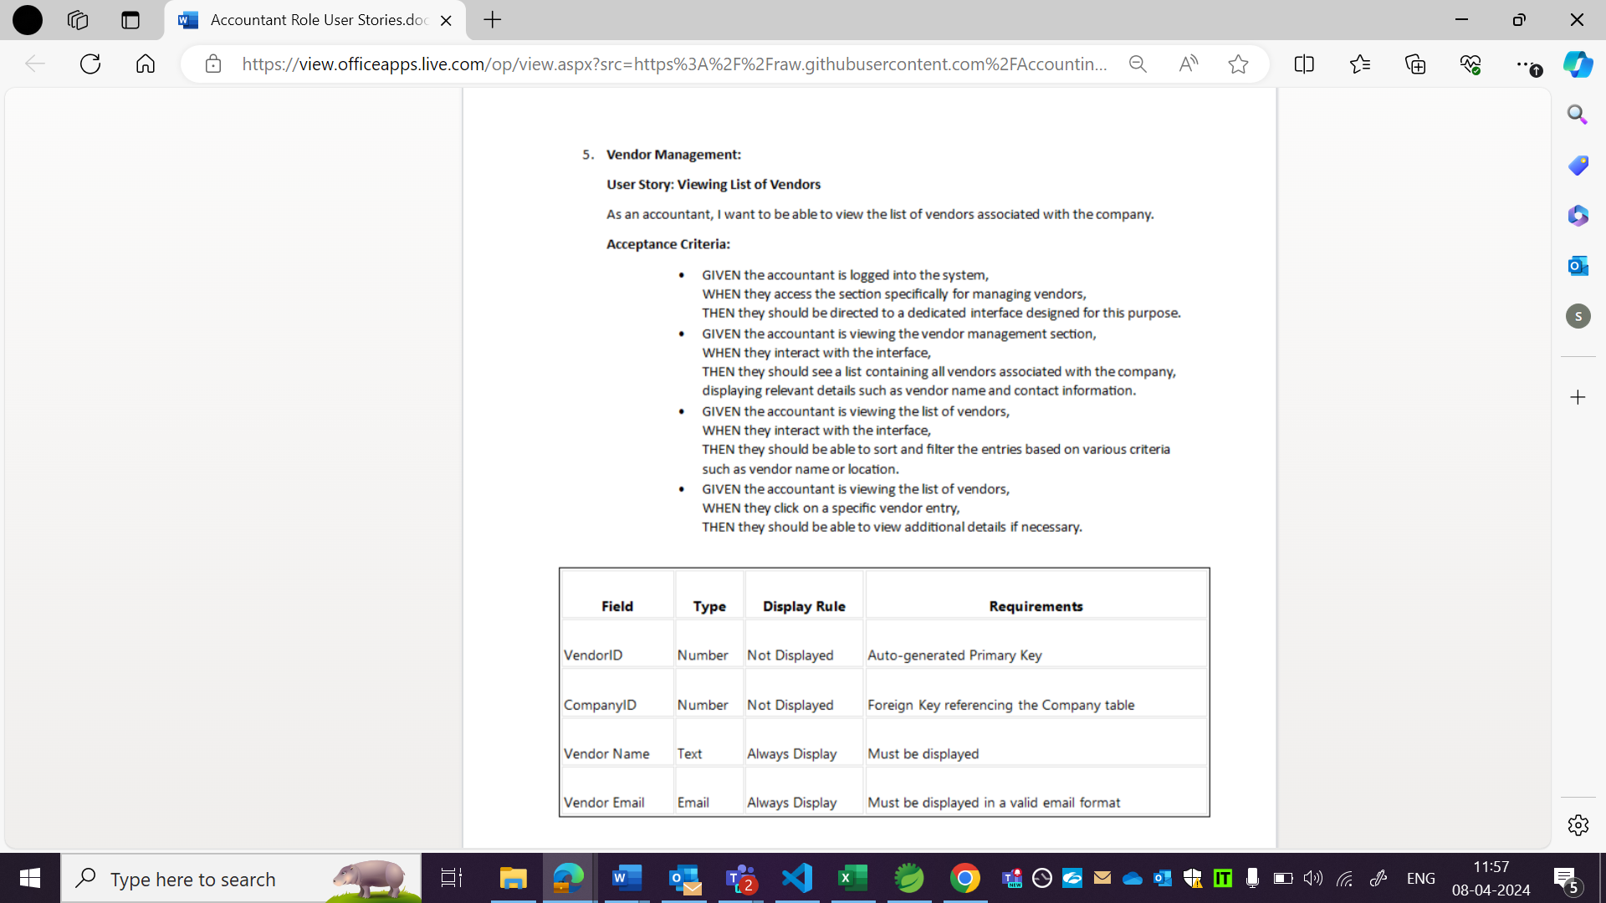

OBSERVATION3:

As per US, sort and filter functionality is not there.

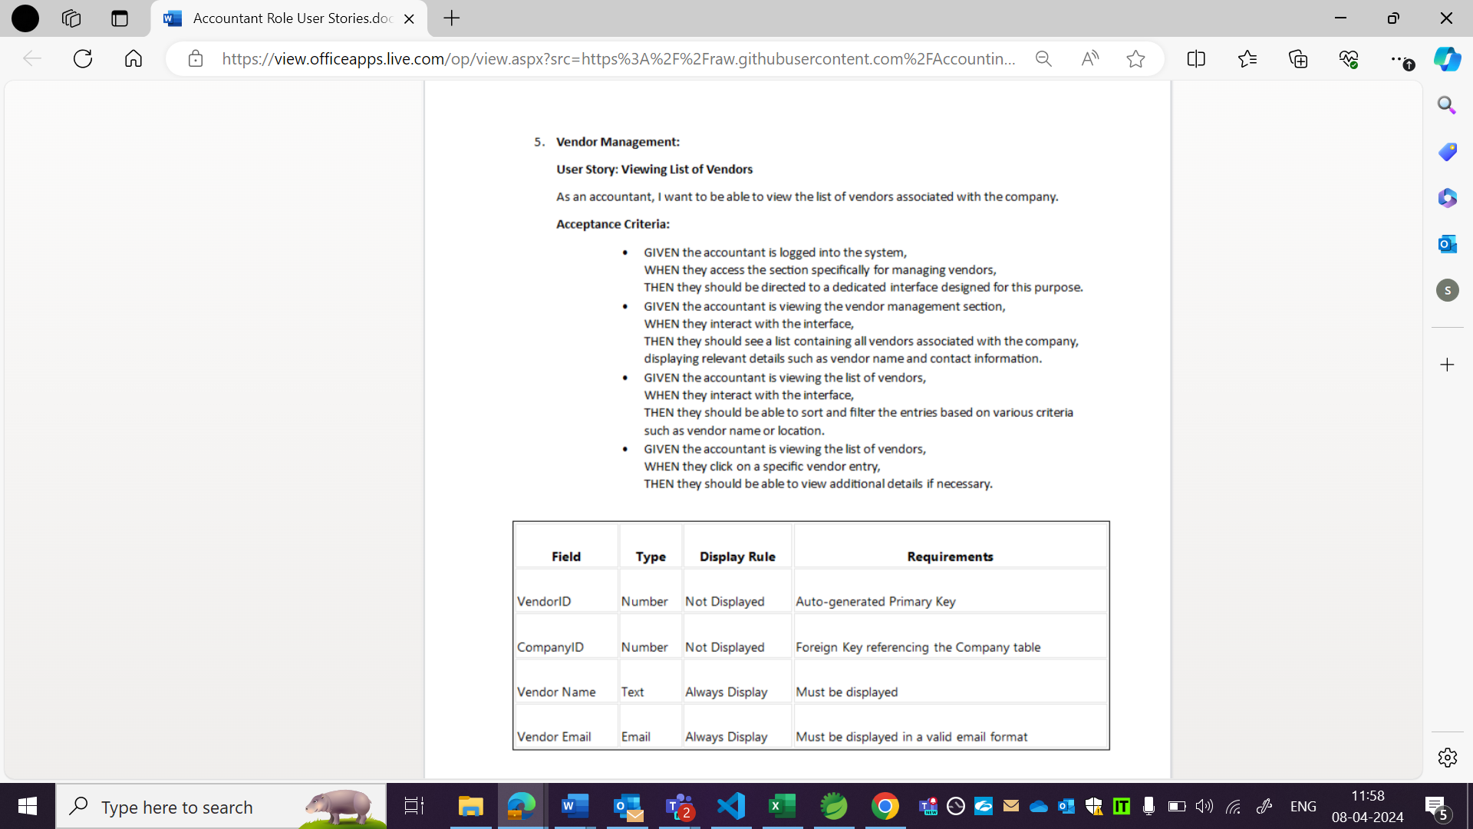

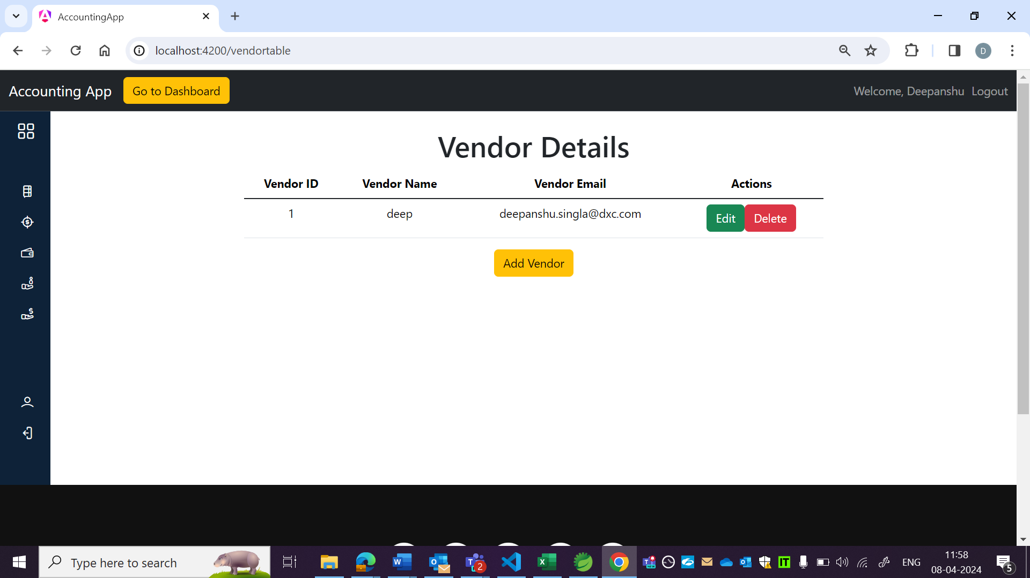

OBSERVATION4:

Content is not in tabular format.

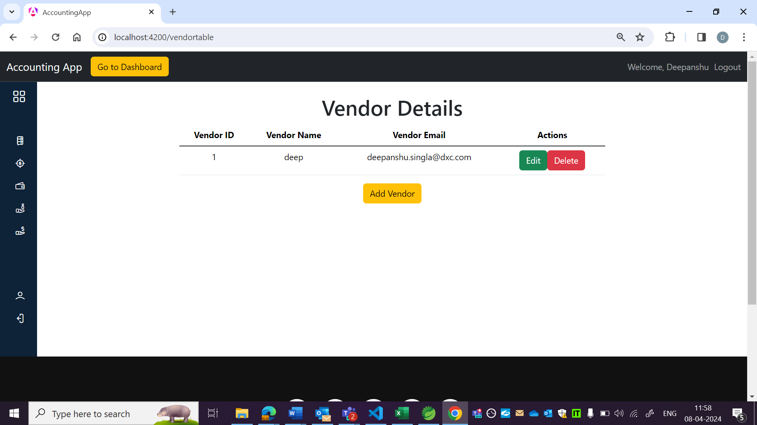

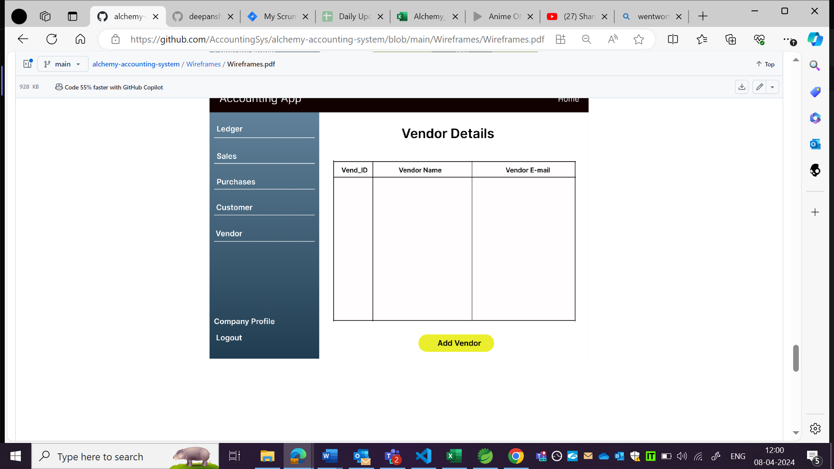

OBSERVATION5:

Background is not as per wireframe.

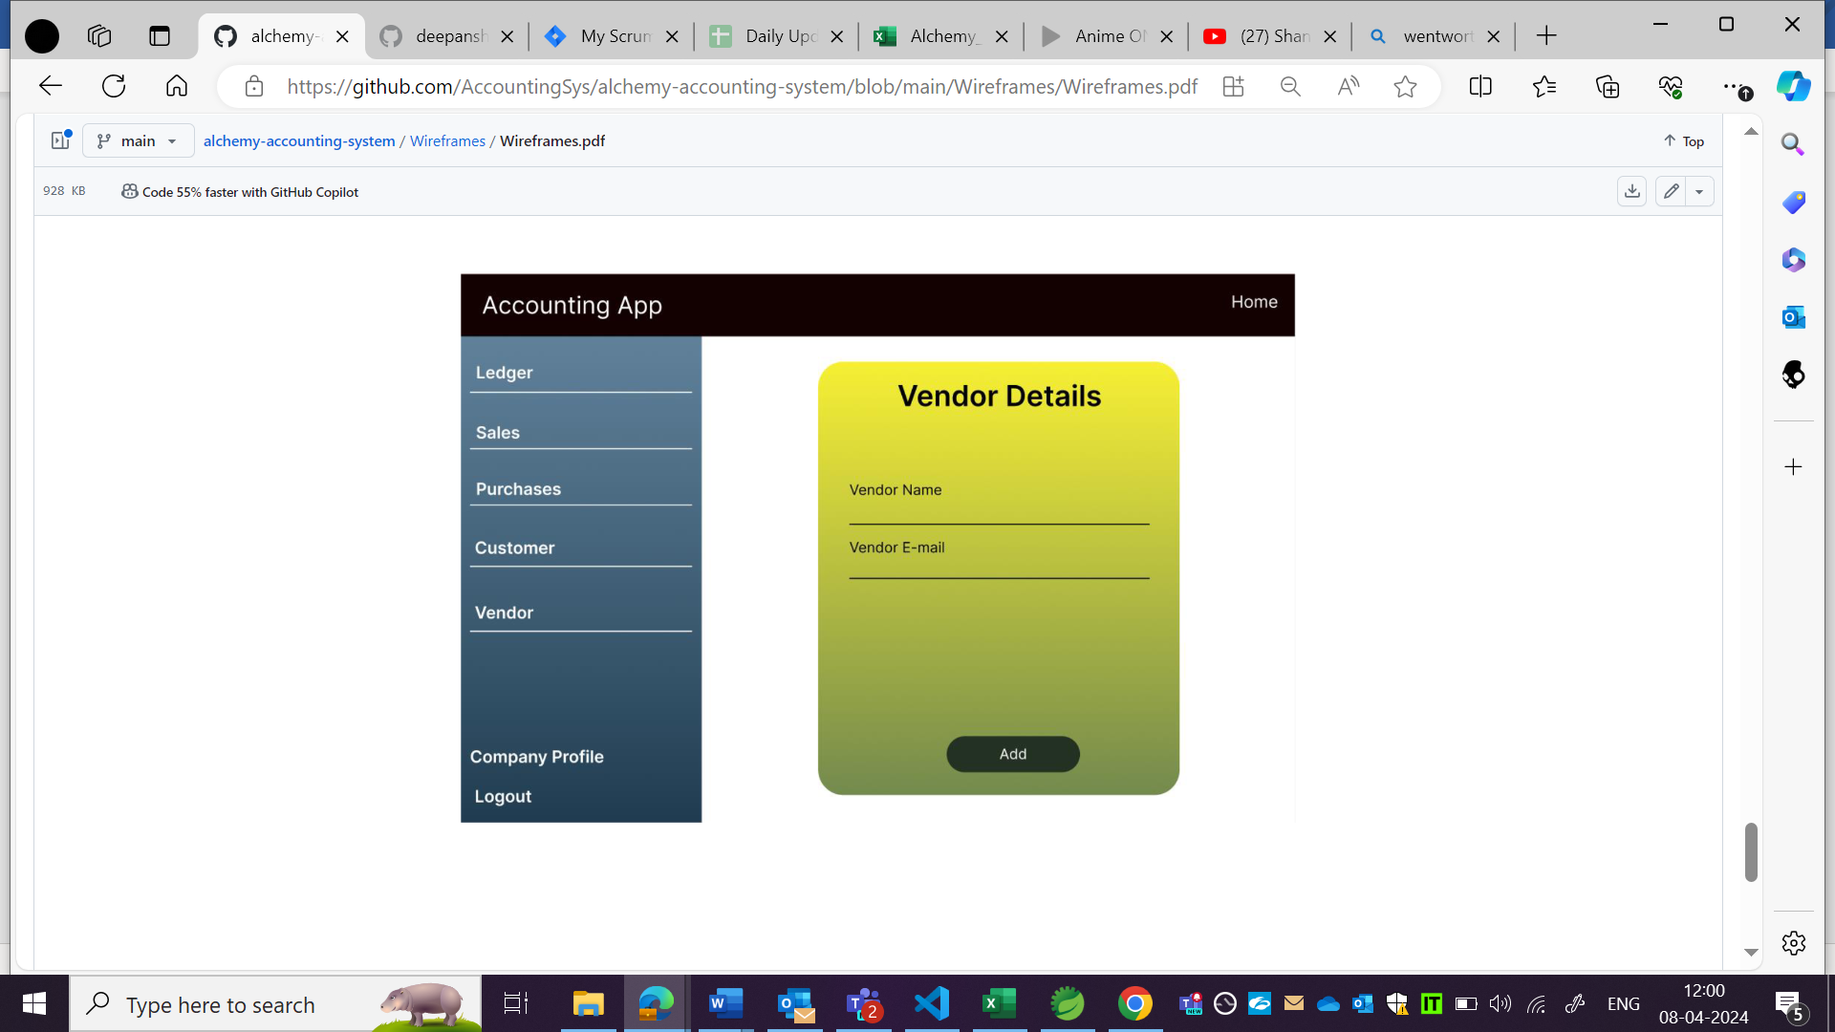

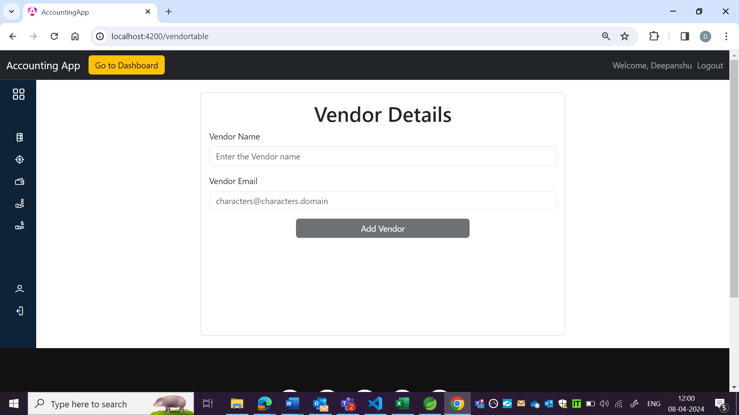

OBSERVATION6:

While editing vendor details, it is accepting vendor name and email without validation.

